1. Problem statement: Please try to configure Internet Explorer browser and Chrome Browser. But before that try to check on the exception you’re getting.

2. code with comments:

Configuring IE:

package com.ibm.seleniumconcepts;

import org.openqa.selenium.WebDriver;

import org.openqa.selenium.chrome.ChromeDriver;

import org.openqa.selenium.firefox.FirefoxDriver;

import org.openqa.selenium.ie.InternetExplorerDriver;

public class SeleniumBrowser {

public static void main(String[] args) {

// TODO Auto-generated method stub

WebDriver driver=new InternetExplorerDriver();

System.out.println("Hello");

}

}

Configuring Chrome:

package com.ibm.seleniumconcepts;

import org.openqa.selenium.WebDriver;

import org.openqa.selenium.chrome.ChromeDriver;

import org.openqa.selenium.firefox.FirefoxDriver;

import org.openqa.selenium.ie.InternetExplorerDriver;

public class SeleniumBrowser {

public static void main(String[] args) {

// TODO Auto-generated method stub

WebDriver driver=new InternetExplorerDriver();

System.out.println("Hello");

}

}

3. Explanation of the code:

To configure Chrome and IE browsers and automate them, we need to first download its respective .exe files – chromedriver.exe and Internetexplorer.exe files and paste it in the eclipse respective project.

4. Result flow in detail:

To configure Chrome and IE browsers and automate them, we need to first download its respective .exe files – chromedriver.exe and Internetexplorer.exe files and paste it in the eclipse respective project.

5. Output screenshot:

Exceptions

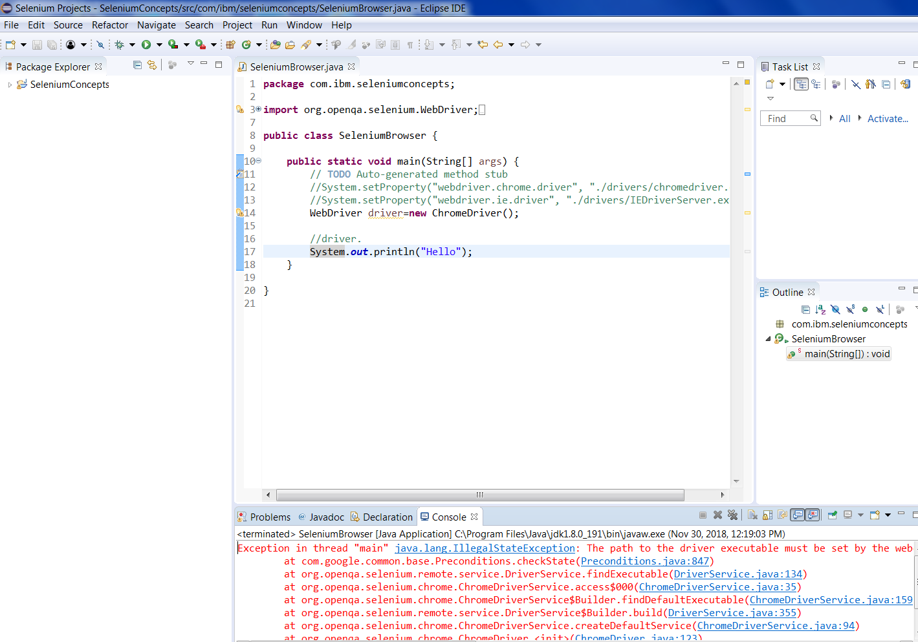

Chrome Output

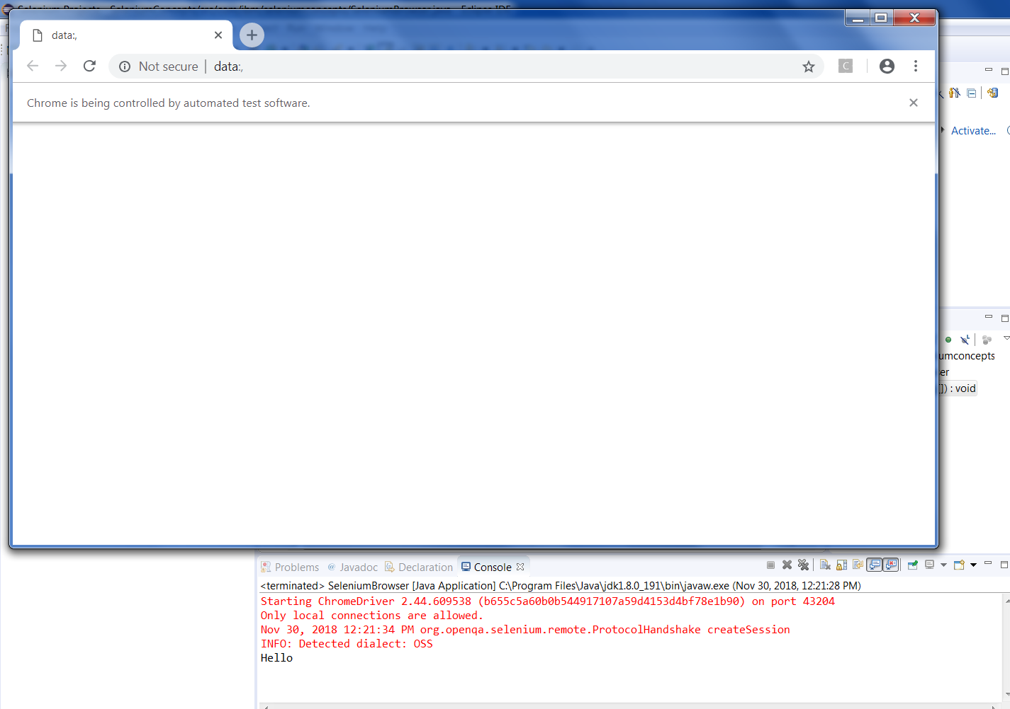

IE Output

